Random Tech Notes
Notes:
- This contains random notes not found in books or tutorial or whatever. Search for the [TOPIC] keyword to find sections
- REMEMBER to do commit to the github repo to have these notes elsewhere
Table Of Contents
(Use the [TOPIC] keyword to find it)
C++ Related
- Macros
- Class Inheritance
- Templates
- Libraries

Linux Related
- Commands

[TOPIC] - Macros
- Using #define can be used to create a macro. In C++, a macro is a rule that defines how input text is converted into replacement output text
- Basic types: object-like macros, function-like macros. No semicolons since its a preprocessor directive
  - Function-like → act like functions, can be considered dangerous
  - Object-like →
    - #define identifier → no substitution text
    - Using with no substitution text makes it fall under conditional compilation.
    - #define identifier substitution_text
    - When the preprocessor encounters identifier, it is replaced with substitution_text. Convention is all caps with underscores as spaces such as THIS_IS_IT.
  - Chain macros → has macros inside macros. Parent is expanded then the child is expanded
- Conditional compilation → This allows you to specify under what conditions something will or won’t compile. Using #ifdef, #ifndef, #endif.
  - The #ifdef preprocessor directive allows the preprocessor to check whether an identifier has been previously #defined. If so, the code between the #ifdef and matching #endif is compiled. If not, the code is ignored
  - The #ifndef says if the macro has not been defined yet, the code between #ifndef and #endif will compile
  - In place of #ifdef PRINT_BOB and #ifndef PRINT_BOB, you’ll also see #if defined(PRINT_BOB) and #if !defined(PRINT_BOB). These do the same, but use a slightly more C++-style syntax
- Object like macros don’t affect other preprocessor directives, it just affects normal code
- Directives are resolved before compilation, top to bottom, file by file basis
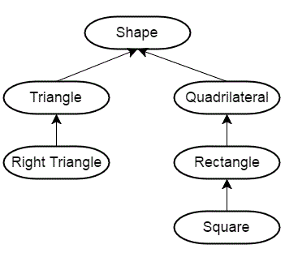
- Once the preprocessor has finished, all defined identifiers from that file are discarded. This means that directives are only valid from the point of definition to the end of the file in which they are defined. Directives defined in one code file do not have impact on other code files in the same project.

[TOPIC] – Class Inheritance
- You can create new objects by directly acquiring the attributes and behavior of the source object, and then extending or specializing them
- A hierarchy can be used to show the relationship of items like progression over time or categorize them moving from more general to more specific. Example to the right
  - Think is-a relationship. A square is a rectangle, but not every rectangle is a square
- A child class inherits both member functions and variables from the parent (with some restrictions). A child class can also have their own members specific to that class
  - The abstraction of having a super class and then subclasses allow for code to not be duplicated, and have it be in one central place.
  - You can keep deriving classes from an already derived class. Using the square, it inherits variables and functions from rectangle, quadrilateral and shape.
- Syntax
  - class BaseballPlayer : public Person { /*code here*/ }
  - This uses public inheritance
- When constructing inherited classes in memory, the most-base class at the top of the inheritance tree is constructed first, then each child is constructed in order, until the most-child class at the bottom of the tree which is constructed last
- What happens when a class is instantiated
  - Normal non-derved class: Memory is set aside → the class constructor is called → member initializer list initializes variables → constructor body executes → control returned to the caller
  - Any derived class: Memory for the derived class is set aside (enough for both the base and derived portions) → derived constructor is called → base object is constructed first using appropriate base constructor, if no base constructor is specified, the default constructor is used → member initializer list initializes variables → body of the constructor executes → control returned to caller
    - The only real difference between this case and the non-inherited case is that before the derived constructor can do anything substantial, the base constructor is called first. The base constructor sets up the base portion of the object, control is returned to the derived constructor, and the derived constructor is allowed to finish up its job.
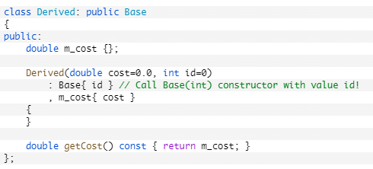
- C++ prevents classes from initializing inherited member variables in the member initializer list of a constructor. The value of member variables can only be set in a member initializer list of the constructor belonging to the same class as the variable
  - We can choose which base class constructor to be called by calling the targeted class constructor in the member initializer list of the derived class. Look to the right
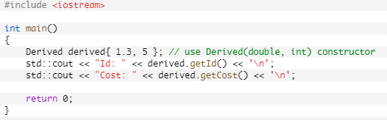
  - Constructors can only call constructors from its immediate parent class. With A → B → C, C cannot call A constructor. C can only call B
  - This example to the right →
    - Memory for derived is allocated.
    - The Derived(double, int) constructor is called, where cost = 1.3, and id = 5.
    - The compiler looks to see if we’ve asked for a particular Base class constructor. We have! So it calls Base(int) with id = 5.
    - The base class constructor member initializer list sets m_id to 5.
    - The base class constructor body executes, which does nothing.
    - The base class constructor returns.
    - The derived class constructor member initializer list sets m_cost to 1.3.
    - The derived class constructor body executes, which does nothing.
    - The derived class constructor returns.
- Private members can only be accessed by member functions of the same class meaning a derived class cannot access private members
- Destructors is called in the reverse order of construction. If constructed A → B → C. Destructing is C → B → A.
[Sub-Topic] Access Specifiers
- The protected access specifier allows the class the member belongs to, friends, and derived classes to access the member. However, protected members are not accessible from outside the class
- Syntax for choosing which level of inheritance. Level of inheritance affect the next derived class. A → B → C, if B inherits privately from A, C cannot access A’s public members because private inheritance means that in B, they are now private members.
  - class Name : public Base {}
  - class Name : protected Base {}
  - class Name : private Base{}
  - When using public inheritance, inherited public members stay public, inherited protected stay protected, and inherited private stay inaccessible
  - With protected inheritance, public and protected members become protected, private members stay inaccessible
  - With private inheritance, inherited private members stay inaccessible, but public and protected members of the base class are (in the subclass) classified as private
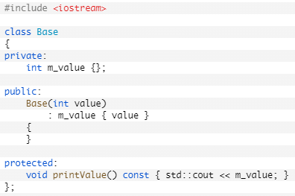
    - Private inheritance can be useful when the derived class has no obvious relationship to the base class, but uses the base class for implementation internally. In such a case, we probably don’t want the public interface of the base class to be exposed through objects of the derived class (as it would be if we inherited publicly).
- You can change an inherited member’s access specifier in the derived class. Look right. Can be changed by:
  - class Derived : public Base {
  - public:
    - ……
    - using Base::printValue;
  - Note the no parenthesis, and since its in the public section of Derived, print value is now a public function if calling from Derived classes
    - This only works for members that the derived class can normally access. This cannot change private members in the base to public or such in the derived
    - Can make a public base member private in the derived class in order to hide functionality in the derived class. This can also be done using the private inheritance syntax instead of public
  - Can also do void printValue() = delete to mark that these cannot be accessed at all through another derived object later
[Sub-Topic] Add Functionality/Functions
- You can add functionality to an already existing base class by making new functions in the derived class. Base class A has m_int. If you cannot change the base class and want to do a get value function, but it doesn’t exist, derived class B can have its own function getValue() {return m_int; } and it works
- IF A→B→C, if A has function getValue(), and B has getValue(), if C name.getValue() is called, the first getValue() function is found in B, so it calls that. If B didn’t have that function, it would find it in A
  - Scope operator can be used if you want to call A::getValue() in B
- Friend functions cannot use the scope resolution. We need to make the derived class temporarily look like the base class to use the base class’s friend functions using std::static_cast<>. This works because the derived class “is-a” base class.
[Sub-Topic] Multiple Inheritance / Mix-Ins
- Use judiciously because it can cause the diamond of doom
- Syntax class Name : public One, public Two to get behavior from both classes
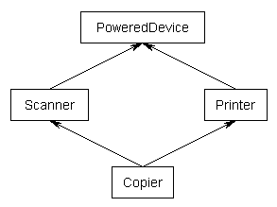
- Common to have mix-ins meaning that this class is intended to NOT be instantiated on its own, but to be mixed into other classes
- Mix-ins typically do not use virtual functions Instead if a mix in needs to be customized, templates are typically used
- Diamond problem, or the “diamond of doom”. This occurs when a class multiply inherits from two classes which each inherit from a single base class. This leads to a diamond shaped inheritance pattern.

[TOPIC] – Templates
- Specifying the parameters of the template tell the compiler what code to run
  - It’s like function overloading, but the code is in one central place
- Syntax:
  - template<typename T>
  - void Print(T value){…}
  - Can also do template<typename T, int N> → and use N with functions that require a known size at compile time such as an array and get around knowing the size at compile time SINCE because it is a template, it is evaluated later
  - doing Print<>(5) will specify you want the template to create the function, versus calling Print(5) → if a function (non-template) Print() exists, the will consider normal functions as well as templated ones
- The template will be evaluated at compile time. It only gets created when the template is called. Further calls to the instantiated function are routed to the already created function for that type
- Can specify the type in the template call such as Print<int>(5) and it will pass the value as an integer. Can also be called without using angled brackets to let type be implicitly deduced
- Can create template classes using the same template parameter declaration (the line above the function declaration) syntax
- Say a template adds 1 to the parameter. If the template function call passes a string as a parameter, it will cause an error since the function definition cannot add 1 to a string
- Template type with different parameter types can be done by template<typename T, typename U> and the template type deduction will take place for both parameters
- Abbreviated function template is used in C++ by using auto as a parameter in a function declaration. Doing Print(auto value) in C++20 is shorthand for template<typename T> void Print(T value)

[TOPIC] – Libraries (from “API Design for C++” by Martin Reddy 2011)
- Libraries allow for pre-packaging compiled code and data that implement your API for use in client applications. They are what makes things modular
- The characteristics, support, and usage of the tools for a library are platform specific. A windows DLL is different from a DSO (dynamic shared object) or SO on Linux systems.
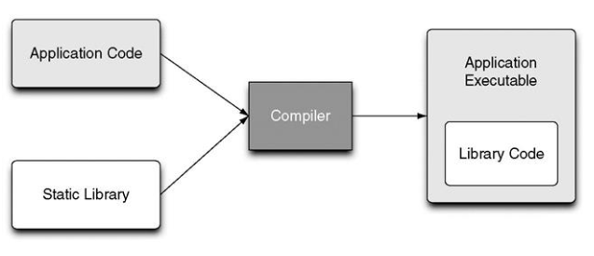
- Static library
  - Contains object code that is linked and becomes part of that executable
  - It is not needed to run the application because the library code is essentially embedded inside the app. This means that the code can be distributed with no additional run-time dependencies
  - If using multiple executables in the project, each executable would increase in size by the amount of the library.
  - Removes possibility of another library being the wrong version for the application
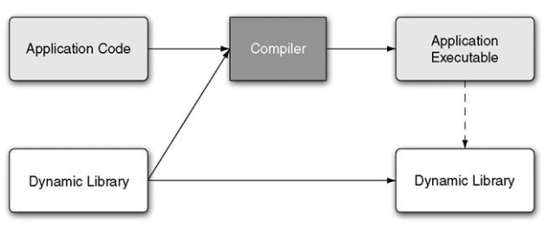
  - If an update comes out for the library, they would need to re-download the whole executable
- Dynamic Library
  - Linked at compile time to resolve undefined references and then distributed with the end-user application so that it can load the library code at run-time
  - Normally requires use of a dynamic linker on the end-user’s machine to determine and load all dynamic libraries and dependencies at run-time
  - Must distribute the dynamic library with the application (as well as others) so that it can be discovered when the app is run
  - Application will not run if the library cannot be found or wrong version
  - Can be more efficient on disk space and memory usage if more than one app relies on the library
  - Binary compatible new versions of the library can be easily loaded to the application
  - If your library you are writing depends on other libraries, these need to be included as well
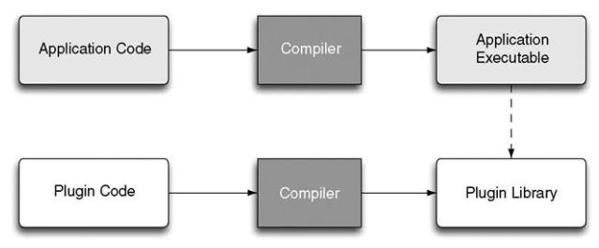
  - Possible for a dynamic library to be loaded on demand without the app having been compiled and linked against that library
    - This can create plugins interfaces, where the app can load additional code at run time that extends the basic capabilities of the program (see right)
- Libraries on Windows
  - static use .lib and dynamic use .dll extensions
    - .dll extensions must be with an import library .lib file. The import library is used to resolve references to symbols exported in the DLL.
    - A static library and an import library are different file types
  - To get a function/class callable from a Windows DLL, must mark it using __declspec(dllexport) followed by the function declaration.
  - To use the exported function, in the import library use __declspec(dllimport)
  - Use pre-processor macros to define export when building the API and use import decoration when using the API in the application. Can also use .def files without the use of the pre-processor macros (in order to not change the source code files) to specify functions to export (more on .def not followed)
  - Optional entry point function when a thread or process loads the DLL done by calling DllMain() that is defined and exported within the DLL. If the entry point returns false, assumed to be a fatal error and the app will fail to start
- Windows utilities
  - tasklist.exe can be used to find out which dynamic libraries a running windows .exe file depends on
    - tasklist /m /fi “IMAGENAME eq APPNAME.EXE”
  - depends.exe will recursively scan a exe to discover all of its dependent DLLs. It will check for missing DLLs, invalid ones, and circular dependencies, among other errors
  - dlister.exe provides log of all DLLs installed on your computer. Can output as a text file or a database file
  - dcomp.exe can display the differences between two DLL listings produced by dlister
  - A.2.5 in “API design for C++” is on loading plugins on windows

Linux

[TOPIC] – Commands
- Alias – alias install=”sudo apt-get” → For making a shortcut for a longer command.
  - Forgets the alias each time you open the command line (unless you modify the command line’s file)
  - install is the shortcut word you want to use instead of the part in quotation marks. The quoted portion is the actual command

- Directory specific
  - Go back a directory → cd -
  - Directly to home directory → cd ~
- Clear screen → clear or CTRL+L (using this just means it moves to top of the window, but can still scroll upwards to see history). reset will clear history
- Remembering directories → pushd followed by directory name will go to that directory. Then can change to others, then use popd to go back to the pushd’s previous directory

